
Associação Nacional de Extensão Rural
Bairro de Natikir
E-mail: aena@aena-mz.org
Website: www.aena-mz.org

AGRA Grant Narrative Report
Grant No: 2017 MZ 006-02

Project Title: Sustainable Market for Smallholder farmers in Nacala Corridor (SMaSh) – Otumiha

Partnership for Inclusive
Agricultural Transformation
in Africa (PIATA)

FINAL REPORT, OCTOBER 01, 2017 TO DECEMBER 31, 2020| JANUARY 5, 2020

Table of Contents
I. Background 1
II Activities 2
2.1. Community Agribusiness Entrepreneur (CAEs/VBAs) identified and trained 2
2.2. Extension services events completed 4
2.2.1. Establishment of demonstration plots 4
2.2.2. Conduction of field days 6
2.2.3. Conduction of trade fairs 7
2.2.4. Promotion of radio programs and ICT demonstration 8
2.3. Distribution of small packs to farmers 9
2.4. Farmers participating in AGRA supported extension services. 10
2.5. Farmers accessing market information supported by AGRA 11
2.6. Training events held to build capacity of farmers and other value chain actors along focus value chains 12
2.7. Individuals who have received AGRA supported short-term agricultural sector training 15
2.8. Extension materials distributed 16
2.9. Market information systems supported 17
2.10. Post-harvest equipment distributed 17
2.11. Establishment of business linkages between seed suppliers and farmers 18
2.12. Graduation of Community Agribusiness Entrepreneur 19
2.13. Creation of climate smart demonstration plots 20
2.14. Leverages 22
III. Achievements 24
IV. Challenges in carrying out the project activities – New Directions 27
V. Learned lessons 28
APPENDIX 1 29
APPENDIX 2 31
APPENDIX 3 32

I. Background
The Otumiha project was implemented in Nacala Corridor by three organizations, namely MIRUKU COOP, AENA and AGMARK. The project goal is to contribute to improvement of food security and livelihoods of the smallholder farmers and their families’ through extension service, inputs and market linkage.
AENA was responsible for extension service including knowledge transfer to farmers; disseminate technologies to production supporting activities, facilitate linkages between agrodealers and farmers as well buyers and farmers. In 3 years, AENA provided extension services to 203,450 smallholder farmers (70,168 women) in 10 districts of Nacala Corridor through 404 Community Agribusiness Entrepreneurs (CAEs).
The project identified and trained 404 CAEs (118 women) on Good Agricultural Practice (GAP) and post-harvest. Each CAE assisted an average of 250 smallholder per cropping season. The CAEs as knowledge and technology disseminator together with their network of 4,000 facilitators established 2,337 demo plots of maize and soybean, and distributed 284,194 small packs to smallholder farmers. The results showed that the CAE could earn about USD 500 of margin per cropping season from input and out market.
The project held 2,793 training events, where were trained 150,522 people on GAP, post-harvest, nutrition and gender equality and equity. The project also conducted 41 field days to promote adoption of new seed varieties and fertilizer use. In the field days, PAN53 and PRIS601 maize varieties, and Wina and Zamboane soybean varieties were chosen as better maize and soybean varieties.
The project facilitated market process through supporting of 8360 market information systems, promotion of 29 business linkage meetings between agrodealers and CAEs, conducting of 12 trade fairs. Yet, the project provided 10 solar pumps to equal number of farmer groups to strengthen their business and increase yearly production.
In these 3 years, there were many learned lessons; however, we just highlighted the following: The youth with a market vision were better suited to succeeded as CAEs in terms of engaging more farmers and disseminating messages than elder CAEs; and the early planting of maize reduced Fall Armyworm attack. Regarding to challenges, the Fall Armyworm was the worst pest for maize crop with much impact on production, and CoVid-19 pandemic brought new dynamic for the project and farmers’ lives.

II Activities
B
In this quarter, the project carried out the following activities:

2.1. Community Agribusiness Entrepreneur (CAEs/VBAs) identified and trained
- Target: 400 CAEs * Achieved: 404 (101%)
The Otumiha project used CAEs extension approach to disseminate knowledge and technologies to smallholder farmers. Apart from promoting extension services, the CAEs are also inputs entry point and first aggregation point of produce in the communities. The margin that CAEs earn from sells is the pathway of sustainability of their business. In these 3 years, the project selected 404 CAEs (118 women) in 10 districts through community participatory meetings. Women (118) represents 29% of the total CAEs engaged (see figure 1). After selection, the CAEs were trained on Good Agricultural Practice (GAP) and marketing.

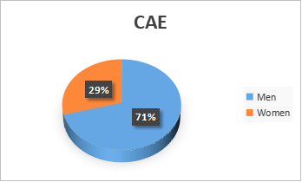
Figure 1. Percentage of CAE by gender.

Table 1. Number of CAEs selected and trained disaggregated by district.
Province | District | Global |  | Total
Province | District | Sex |  | Total
Province | District | Male | Female | Total
Nampula | Malema | 28 | 16 | 44
Nampula | Meconta | 21 | 19 | 40
Nampula | Monapo | 23 | 17 | 40
Nampula | Murrupula | 35 | 5 | 40
Nampula | Rapale | 28 | 12 | 40
Nampula | Ribáuè | 28 | 12 | 40
Niassa | Cuamba | 34 | 6 | 40
Niassa | Mecanhelas | 30 | 10 | 40
Zambézia | Alto-Molocué | 24 | 16 | 40
Zambézia | Gurué | 35 | 5 | 40
Total |  | 286 | 118 | 404

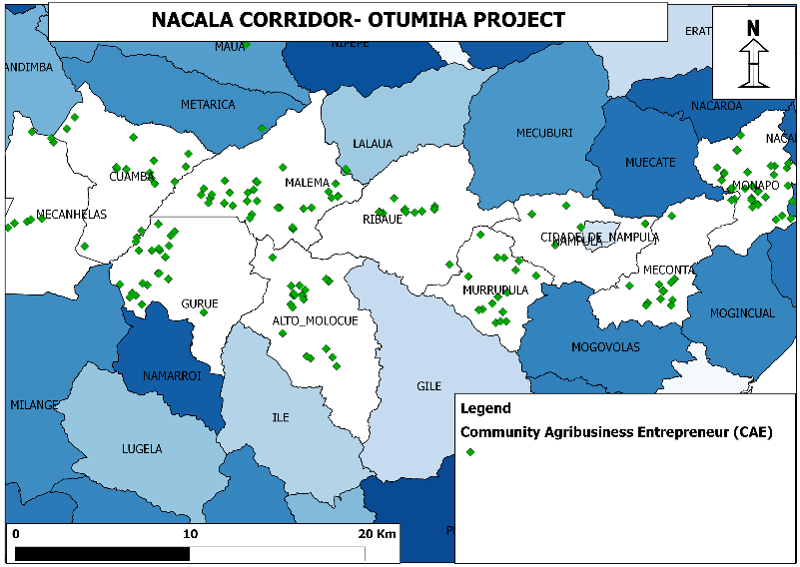
Figure 2. Community Agribusiness Entrepreneur's map.

2.2. Extension services events completed
- Target: 740 events * Achieved: 42,213 (6,110%)
Extension services events refer to all activities that are carried out to promote or disseminate knowledge or technologies for increasing of crop production and productivity. In this section, the project developed activities such as demonstration plots, field days, trade fairs, radio programs, ICT demonstrations and seed packs distribution. Overall, the project had a target of 740 events, and 42,213 events were carried out during the project lifespan. The number of 42,213 events was due the introduction of small packs and baby demos in the communities that were not part of project original plan. These small packs and baby demos aimed to strength the dissemination network of knowledge and technologies from a mother demo into the communities as well to cover as many farmers as possible in the one community. The activities brought visible changes for the SHFs in the communities. From the second cropping season, about 40,000 SHFs reported that are planting in line, or are using mulching, or are buying improved seeds.

2.2.1. Establishment of demonstration plots
- Target: 670 demos * Achieved: 2,337(349%)
In these 3 years, the project facilitated the establishment of 2,337 demo plots of maize and soybean crops through CAEs and facilitators. Among them, 667 were mother demos and other 1,660 were baby demos. The CAEs were responsible to establish mother demos, while the facilitators were responsible to establish baby demos (see layouts of mother and baby demos are shown in the appendix 1) Mother demo was the main demonstration plot, where all maize and soybean varieties promoted by project were sown to be disseminated to smallholder famers through CAEs. While, baby demo was a replication of maize or soybean variety picked up from mother demo as strategy to spread many demos in the large communities to cover as many smallholder farmers as possible. The demos were the key for creation of demand for new crop varieties and adoption of new techniques. On the other hand, the demos served to demonstrate technologies and practices resilient to climate change such as drought tolerant varieties, Molocue and ZM523 (maize crop), Zamboane and Sana (soybean crop), it was also demonstrated the use of mulching in the districts (Meconta, Murrupula and Monapo) where the rainfall is low (sometimes less than 600mm) and irregular. All 404 CAEs and about 4,000 facilitators have adopted plating in line, good planting density, use of improved seed. In addition, about 21,345 SHFs were convinced to buy improved seed or fertilizer, where 9,215 bought soybean seed while in their community soybean was introduced in 2 years before. The table below shows the demos distributed per district.

Table 2. Number of demo plots per district.
Province | District | Demo |  | Cumulative demo plots
Province | District | Mother | Baby | Cumulative demo plots
Nampula | Malema | 68 | 199 | 267
Nampula | Meconta | 36 | 92 | 128
Nampula | Monapo | 76 | 92 | 168
Nampula | Murrupula | 68 | 287 | 355
Nampula | Rapale | 74 | 86 | 160
Nampula | Ribáuè | 69 | 118 | 187
Niassa | Cuamba | 69 | 297 | 366
Niassa | Mecanhelas | 65 | 68 | 133
Zambézia | Alto-Molocué | 81 | 238 | 319
Zambézia | Gurué | 71 | 183 | 254
Total |  | 667 | 1,660 | 2,337

2.2.2. Conduction of field days
- Target: 60 field days *Achieved: 41 field days (68%)
The project planned to conduct 60 field days in 3 cropping seasons (20 field days per season). However, due to Covid-19 pandemic, 19 field days were cancelled in 2020.
In these 41 field days, a total of 6,788 people (2,616 women) participated in the 10 target districts (see table 3). The 2,616 women represents about 39% (see fig. 4), which shows that there was women’s interest to attend this type of events to get more knowledge of crop production. The purpose of field days was to show new improved varieties of maize and soybean, effects of fertilizer application, explanation of differences between seed varieties and its impacts on productivity and market, and creation of adoption. Besides, the field days served to exchange experience between value chain actors (farmers, agrodealers, SMEs, etc.).
District Administrators, Directors of SDAE, all CAEs of the district, agrodealers, and seed companies, SMEs, project team, farmers and other stakeholders attended the field days. It is important to refer that the seed company KLEIN KAROO (K2) participated in almost all field days to explain about their seed varieties (maize: Pris601 and soybean: Lundi and Mwezeni).
During the field days, there were variety choosing moments. The farmers chose Pris601 and PAN53 varieties as the best of the five (ZM523, SP1 MRI521, PAN53 and Pris601). While, for soybean crop, all four varieties (Wima, Zamboane, Lundi and Mwezeni) were chosen by farmers based on the agro-ecological conditions of the districts. In the districts of Meconta, Murrupula and Rapale, the farmers preferred Wima and Zamboane, because they were drought tolerant, while Mecanhelas and Cuamba preferred Mwezeni and Lundi because they had high yields.
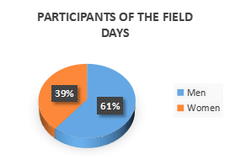
Figure 3. Percentage of beneficiaries who attended field days disaggregated by gender.
Table 3. Number of field days and participants per district
Province | District | Number of field days | Participants |  | Total of participants
Province | District | Number of field days | Sex |  | Total of participants
Province | District | Number of field days | Men | Women | Total of participants
Nampula | Malema | 3 | 305 | 200 | 505
Nampula | Meconta | 2 | 226 | 45 | 271
Nampula | Monapo | 6 | 626 | 503 | 1,129
Nampula | Murrupula | 4 | 330 | 164 | 494
Nampula | Rapale | 4 | 631 | 374 | 1,005
Nampula | Ribáuè | 4 | 540 | 333 | 873
Niassa | Cuamba | 4 | 302 | 128 | 430
Niassa | Mecanhelas | 4 | 397 | 350 | 747
Zambézia | Alto-Molocué | 5 | 461 | 274 | 735
Zambézia | Gurué | 5 | 354 | 245 | 599
Total |  | 41 | 4,172 | 2,616 | 6,788
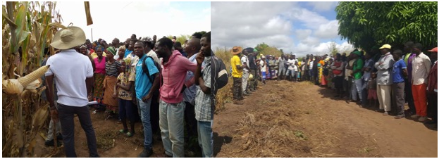
Figure 4. left photo: K2 representative explaining to farmers the advantages of improved seeds; right photo: CAE showing to the farmers the improved varieties planted in the demos.

2.2.3. Conduction of trade fairs
- Target: 10 trade fairs * Achieved: 12 trade fairs (120%)
The project organized 12 trade fairs, being 1 regional fair, 1 provincial fair, and 9 district fairs. Regional fair was organized in Gurué district; this was the greatest event among the extension events. In this fair, beneficiaries from 3 provinces (Nampula, Zambézia and Niassa) participated. Provincial fairs were organized in 3 districts namely: Monapo Rapale and Ribáuè districts; in those fairs only beneficiaries from Nampula province were involved. The project also organized 8 district fairs in Malema (1), Meconta (1), Monapo (1), Murrupula (1), Ribáuè (1), Cuamba (1), Mecanhelas (1) and Gurué (1) districts. The participants of the district fairs were local (from the district where the fair was organized).

The objectives were to expose, promote and commercialize good maize and soybean varieties. Besides, another aim was to promote experience exchange among value chain actors (CAEs, smallholder farmers, agro-dealers and buyers). It is important to refer that the fairs were organized in coordination with provincials and districts Government, input suppliers, output buyers, research institutions (Kickstart Int., Potato International Center, GF Macadamia, K2, PANNAR, IIAM, CLUSA, IITA, TOM Magoma, Oruwera and AGRICOM). The table 4 shows the trade fairs organized by the project. The 2020 market season, about 46 CAEs reported that have aggregated farmers ‘produce and participated in the local trade fairs.

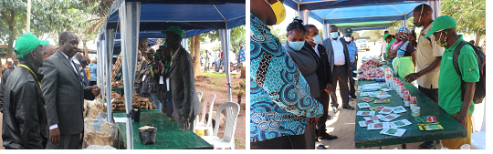

Figure 5. Left photo: district administrator interacting with CAE (Gurué): right photo: Government Representatives interacting with agro-dealer (Monapo)

This activity created more interesting of CAEs in participating local trade fairs. In

Table 4. Type and number of trade fairs per district.
Province | District | Regional trade fair | Provincial trade fair | District trade fair | Total
Nampula | Malema | 0 | 0 | 1 | 1
Nampula | Meconta | 0 | 0 | 1 | 1
Nampula | Monapo | 0 | 1 | 1 | 2
Nampula | Murrupula | 0 | 0 | 1 | 1
Nampula | Rapale | 0 | 1 | 0 | 1
Nampula | Ribáuè | 0 | 1 | 1 | 2
Niassa | Cuamba | 0 | 0 | 1 | 1
Niassa | Mecanhelas | 0 | 0 | 1 | 1
Zambézia | Alto-Molocué | 0 | 0 | 0 | 0
Zambézia | Gurué | 1 | 0 | 1 | 2
Total |  | 1 | 3 | 8 | 12

2.2.4. Promotion of radio programs and ICT demonstration
- Target: 720 * Achieved: 1,180 (164%)
Radio programs and AENASicom were platforms used to disseminate messages on Good Agricultural Practices (GAP), field days, trade fairs and market (location of produce, people buying produce and prices). AENA signed annual contract with 8 community radios (Monapo, Namialo-Meconta, Ribáuè, Malema, Cuamba, Mecanhelas, Alto-Molocué and Gurué) to cover the same number of districts. Murrupula and Rapale districts have no community radios, so AENA used Radio Haq or Radio Moçambique (both are based in Nampula City) to cover the same contents in those two districts. On the other hand, AENA signed annual contract with Vodacom Mobile Company to connect AENASicom platform with beneficiaries. AENASicom is a platform managed by AENA, where farmers ‘cellphone numbers are registered to receive agricultural information or other relevant. Thus, AENA can record the number of beneficiaries that are receiving messages. For this project, about 4404 (404 CAEs and 4000 facilitators) were registered on the platform. This allowed to the farmers receive messages on time for their usage.
The messages disseminated to the farmers were very useful. About 350 CAEs reported that they used the given advices to control fall armyworm in their fields, thus avoiding decreasing of yields. Besides, they used the same information to disseminate to their farmers and communities. The table below shows number of radio programs and ICT demonstrations per district.

Table 5. Number of radio programs and ICT demonstrations per district.
Province | District | Radio programs | ITC demonstrations | Total
Nampula | Malema | 31 | 86 | 117
Nampula | Meconta | 34 | 84 | 118
Nampula | Monapo | 32 | 135 | 167
Nampula | Murrupula | 10 | 85 | 95
Nampula | Rapale | 10 | 111 | 121
Nampula | Ribáuè | 22 | 84 | 106
Niassa | Cuamba | 22 | 87 | 109
Niassa | Mecanhelas | 26 | 84 | 110
Zambézia | Alto-Molocué | 10 | 120 | 130
Zambézia | Gurué | 10 | 97 | 107
Total |  | 207 | 973 | 1,180
Apart from the extension events above mentioned, the project also carried out seed packs distribution as extension event. However, this activity will be detailed in the small packs distribution section.

2.3. Distribution of small packs to farmers
- Target: 200,000 * Achieved: 284,194 (142%)
The small packs distribution was one of the extension strategy to cover large number of smallholder farmers. There were 2 types of small packs; (i) 50g of hybrid maize seed or 100g of soybean seed, and (ii) 200g of fertilizer (a blend). The purpose of the small packs distribution was to ensure that beyond mother and baby demos every single smallholder farmer could experiment improved seed and fertilizer in his/her farm. This approach allowed smallholder farmers to learn by doing and to make decisions about crop varieties and fertilizer that they can use from their own experiences.
The project distributed 284,194 small packs to farmers, where 142,019 were packs of seeds and other 142,019 were packs of fertilizer. Each beneficiary received as a kit, one small pack of seed and another of fertilizer. Before the distribution, the smallholder farmers were trained on planting space, fertilizer use and planting density through CAEs and facilitators. The small packs created great changes on the farmers mindset, about 80% of SHFs who received the packs reported that they were interested to buy improved seed and fertilizer, however, the price of fertilizer (about USD 40 per bag of 50) was major limitation for their willing. The below table shows number of distributed small packs per district.

Table 6. Number of distributed small packs per district
Province | District | Small packs |  | Total
Province | District | Seed | Fertilizer | Total
Nampula | Malema | 13,444 | 13,444 | 26,888
Nampula | Meconta | 13,200 | 13,200 | 26,400
Nampula | Monapo | 17,900 | 17,900 | 35,800
Nampula | Murrupula | 15,700 | 15,700 | 31,400
Nampula | Rapale | 17,500 | 17,500 | 35,000
Nampula | Ribáuè | 11,023 | 11,023 | 22,046
Niassa | Cuamba | 11,600 | 11,600 | 23,200
Niassa | Mecanhelas | 12,035 | 12,035 | 24,070
Zambézia | Alto-Molocué | 14,200 | 14,500 | 29,000
Zambézia | Gurué | 15,195 | 15,195 | 30,390
Total |  | 142,097 | 142,097 | 284,194

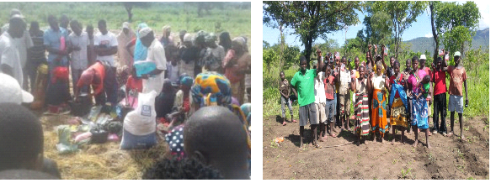
Figure 6. Left photo: small pack distribution process in Monapo; right photo: beneficiaries after receiving small packs in Gurué.

2.4. Farmers participating in AGRA supported extension services.
- Target: 155,750 * Achieved: 203,450 (131%)
The project used Community Agribusiness Entrepreneur (CAE) or Village-Based Advisor (VBA) extension approach to cover smallholder farmers in 10 districts. The extension team had a strategic coordinator (project manager) and 10 district technicians (1 per district), where each technician supported 40 CAEs, each CAE supported 10 facilitators and each facilitator assisted 25 smallholder farmers as shown in the figure 7. The extension structure installed was able to support, with extension services about, 100,000 smallholder farmers per cropping season.
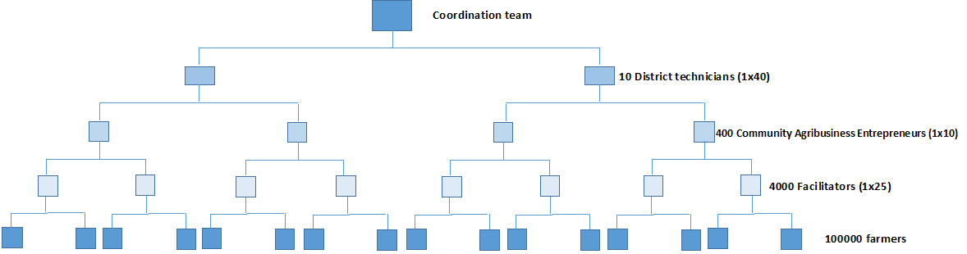
Figure 7. Diagram of the CAE/VBA extension approach used in the Otumiha project.
The main extension services provided to smallholder farmers were trainings on GAP and post-harvest, dissemination of GAP and market messages through radio, AENASicom platform and leaflets, field days, trade fairs and distribution of small packs. In 3 cropping seasons, the project supported 203,450 (70,168 women) smallholder farmers. The table below shows farmers supported by project per district.

Table 7. Number of farmers participating in AGRA supported extension services.
Province | District | Assisted farmers with AGRA support |  | Total
Province | District | Male | Female | Total
Nampula | Malema | 13,269 | 6,906 | 20,175
Nampula | Meconta | 14,199 | 5,726 | 19,925
Nampula | Monapo | 18,013 | 8,905 | 26,918
Nampula | Murrupula | 12,213 | 6,378 | 18,591
Nampula | Rapale | 14,675 | 8,891 | 23,566
Nampula | Ribáuè | 11,807 | 6,238 | 18,045
Niassa | Cuamba | 12,600 | 5,712 | 18,312
Niassa | Mecanhelas | 11,889 | 6,616 | 18,505
Zambézia | Alto-Molocué | 10,459 | 7,446 | 17,905
Zambézia | Gurué | 14,158 | 7,350 | 21,508
Total |  | 133,282 | 70,168 | 203,450

2.5. Farmers accessing market information supported by AGRA
- Target: 4,040 * Achieved: 16,224 (402%)
The project planned to disseminate market information to farmers using other farmers (CAE/VBA) as entry points, i.e., the messages reached smallholder farmers through 404 CAEs and 4,000 facilitators, which were farmers’ group leaders or supporters. The project registered CAEs and facilitators’ mobile numbers on the AENAsicom platform. Thus, the market information was sent from the platform to CAEs and facilitators. Thereafter, they disseminated the information to their farmers’ network. Apart from CAEs and facilitators, there were farmers with mobile phones registered to be the part services users. In 3 market seasons, the project facilitated 16,224 farmers (4,027 women) to receive market information as shown in the table 8. This information, on one hand brought updated prices to farmers, and on the other hand it gave farmers more power to decide when, where and to whom to sell the produce at fair price.

Table 8. Number of Farmers accessing market information per province
Province | Global |  | Total
Province | Sex |  | Total
Province | Male | Female | Total
Nampula | 8,704 | 2,909 | 11,613
Niassa | 627 | 392 | 1,019
Zambézia | 2,866 | 726 | 3,592
Total | 12,197 | 4,027 | 16,224

2.6. Training events held to build capacity of farmers and other value chain actors along focus value chains
- Target: 1,484 * Achieved: 2,793(188%)
The project conducted 2 main types of trainings namely: Good Agricultural Practice and Post-Harvest. In addition, the project conducted other trainings on nutrition and gender equality and equity. The project planned to hold 1,484 trainings. This plan included training of trainers (ToT), training of CAEs and trainings of smallholder farmers through CAEs. Nevertheless, 2,793 trainings were held, the previous plan was to train 25-30 smallholder farmers per event, but the trainings we mostly conducted with 15-20 smallholder farmers per event. Besides, during Covid-19, the project had to reduce the number of participants from 20 to 10 per training and increase the number of training events to cover all planned farmers to be trained. The trainings were organized in the following methodology: (i) specialists trained the technician as ToT; (ii) technicians trained CAE and facilitators; (iii) CAE and facilitators replicated the trainings to the smallholder farmers. In 3 years, the project conducted 2,793 training events, where 1,806 were on GAP, 953 on post-harvest and 34 others. The table 9 shows the number of trainings events per district.

Table 9. Number of training events to build capacity of farmers and other value chain actors along focus value chains per district.
Province | District | Type of training |  |  | Total
Province | District | GAP | Post-harvest | Other | Total
Nampula | Malema | 94 | 104 | 3 | 201
Nampula | Meconta | 219 | 105 | 3 | 327
Nampula | Monapo | 207 | 71 | 3 | 281
Nampula | Murrupula | 90 | 75 | 3 | 168
Nampula | Rapale | 341 | 158 | 3 | 502
Nampula | Ribáuè | 142 | 78 | 3 | 223
Niassa | Cuamba | 275 | 110 | 3 | 388
Niassa | Mecanhelas | 207 | 59 | 3 | 269
Zambézia | Alto-Molocué | 126 | 111 | 3 | 240
Zambézia | Gurué | 105 | 82 | 7 | 194
Total |  | 1,806 | 953 | 34 | 2,793

The training of trainers on GAP to technicians was held by AGRA head of extension (Paul Seward). This training had the following content:
- Preparation of cropping season (plans, planting date, overthrow, farming, etc);
- Planting space, planting density and fertilizer application;
- Weed control;
- Pest and disease management.
After the opening training, the technicians trained CAEs and facilitators, then the CAEs and facilitators trained smallholder farmers. This process ended with 1,806 trainings on GAP. The figure below shows different steps of trainings.

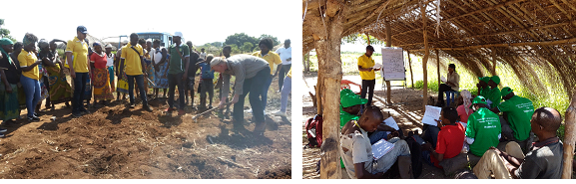
Figure 8. Left photo: Paul Seward was training the project team; right photo: project technician was training the CAEs.
Regarding to post-harvest, the project in coordination with HELVETAS Swiss Intercooperation conducted 953 trainings on post-harvest in 3 phases as described below.

Phase 1. HELVETAS Swiss Intercooperation trained 10 technicians as trainers on post-harvest. The contents delivered were following:
- Post-harvest management;
- Grain drying techniques;
- Control of grain moisture;
- Types of storage, and;
- Improved barns.

Phase 2. The technicians trained the CAEs. In this phase, 20 trainings events were conducted in 10 districts with monitoring of HELVETAS team. In each district the trainings were conducted by technician in 2 communities, where each 50% of CAEs attended in one side.

Phase 3. The CAEs trained smallholder farmers. In this phase, 942 trainings on post-harvest were conducted in 10 districts. As result of the trainings, 14,983 farmers (5,008 women) were trained by VBAs on post –harvest. Figure 12 shows VBA training farmers. It is important refer that some field days were carried out to demonstrate post-harvest techniques and promote some post-harvest technologies. The project promoted 4 types of post-harvest technologies namely: hermetic bags, mechanic thresher, slabs (cemented floor) and actelic. The figure below shows two different phases of trainings.

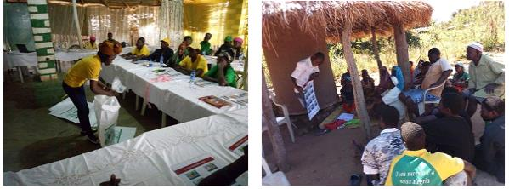
Figure 9. Left photo: technician was showing to use hermetic bag to CAEs; right photo: CAE was showing the steps from harvest to storage to the smallholder farmers.

As it was mentioned before, there were trainings on gender equality and nutrition. The trainings aimed to provide knowledge to CAEs in nutritional value of soybeans, how to make soy milk, how to make bagias of soybeans (soy flour fries); land law and access to land for women. The trainings on nutrition were conducted in coordination with Nossara Cooperative (based in Gurué district), while trainings on gender were led by Gender officer from AENA. In total, 34 trainings were conducted.

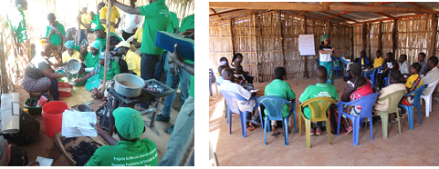
Figure 10. Left photo: preparing soybean milk process (nutrition session); right photo: Men and women relationships in the households (gender session).
Overall, the trainings brought great changes in the farmers’ practice. About 90% of visited farmers groups (206 in 10 districts) after trainings reported that they have changed from traditional practice to new ones. Post-harvest practices were referred more prominently, the farmers mentioned that already started use tarps and plastics for drying their produce, they do moisture content test of grains before packing, they use actelic to control warehouse pest or use hermetic bags to store their produce.

2.7. Individuals who have received AGRA supported short-term agricultural sector training
- Target: 108,400 * Achieved: 150,522 (139%)
The project considered trained actors those individuals (CAEs, facilitators, project technicians, public extension workers) who have attended at least one of 2,793 training events on GAP, post-harvest, nutrition and gender held or co-coordinated by Otumiha project. In 3 years, the project trained 150,522 individuals (51,105 women). The table below shows the trained individuals per district.

Table 10. Number of individuals who have received AGRA supported short-term trainings per district.
Province | District | Individuals received short-term trainings |  | Total
Province | District | Male | Female | Total
Nampula | Malema | 11,682 | 6,865 | 18,547
Nampula | Meconta | 9,695 | 3,086 | 12,781
Nampula | Monapo | 11,502 | 6,340 | 17,842
Nampula | Murrupula | 12,931 | 6,262 | 19,193
Nampula | Rapale | 12,285 | 7,046 | 19,331
Nampula | Ribáuè | 6,335 | 3,251 | 9,586
Niassa | Cuamba | 8,587 | 3,089 | 11,676
Niassa | Mecanhelas | 7,226 | 4,290 | 11,516
Zambézia | Alto-Molocué | 7,069 | 5,124 | 12,193
Zambézia | Gurué | 12,105 | 5,752 | 17,857
Total |  | 99,417 | 51,105 | 150,522

2.8. Extension materials distributed
- Target: 15,000 * Achieved: 30,254 (201%)
Province | District | Demo sign board | Cell phone | Bicycle | Registration book | Leaflet | Pen | T-shirt | Bag | Hat | Stamp pad | Flipchart | Marker box | Sprayer | Rope | Tape-measure
Nampula | Malema | 2 | 40 | 3 | 663 | 876 | 663 | 440 | 40 | 40 | 55 | 55 | 55 | 13 | 40 | 40
Nampula | Meconta | 2 | 40 | 3 | 663 | 876 | 663 | 440 | 40 | 40 | 55 | 55 | 55 | 13 | 40 | 40
Nampula | Monapo | 2 | 40 | 3 | 663 | 880 | 663 | 440 | 40 | 40 | 55 | 55 | 55 | 13 | 40 | 40
Nampula | Murrupula | 2 | 40 | 3 | 663 | 876 | 663 | 440 | 40 | 40 | 55 | 55 | 55 | 13 | 40 | 40
Nampula | Rapale | 2 | 40 | 3 | 663 | 876 | 663 | 440 | 40 | 40 | 55 | 55 | 55 | 13 | 40 | 40
Nampula | Ribáuè | 2 | 40 | 3 | 663 | 876 | 663 | 440 | 40 | 40 | 55 | 55 | 55 | 13 | 40 | 40
Niassa | Cuamba | 2 | 40 | 3 | 663 | 876 | 663 | 440 | 40 | 40 | 55 | 55 | 55 | 13 | 40 | 40
Niassa | Mecanhelas | 2 | 40 | 3 | 663 | 876 | 663 | 440 | 40 | 40 | 55 | 55 | 55 | 13 | 40 | 40
Zambézia | A-Molocué | 2 | 40 | 3 | 663 | 876 | 663 | 440 | 40 | 40 | 55 | 55 | 55 | 13 | 40 | 40
Zambézia | Gurué | 2 | 40 | 3 | 663 | 876 | 663 | 440 | 40 | 40 | 55 | 55 | 55 | 13 | 40 | 40
Total |  | 20 | 400 | 30 | 6,630 | 8,764 | 6,630 | 4,400 | 400 | 400 | 550 | 550 | 550 | 130 | 400 | 400
The project acquired extension materials such as demo sign board, cell phones, bicycles t-shirts, ropes, tape-measures, etc., and distributed to CAEs and facilitators. Q4-2017 to Q3-2019. These materials were provided as kits to CAEs and facilitators for daily work. They used theses kits to register the smallholder farmers, establish demo plots, communicate with agro-dealers and SHEs, to keep the record of sells, so on. The project clarified that the kits were not salaries or subsidies, but work materials for the knowledge disseminators (CAEs and facilitators). Over all, the project distributed 30,254 units of extension materials and the table below shows the detail per district.

Table 11. Number of extension materials distributed per district.

2.9. Market information systems supported
- Target: 8,000 * Achieved: 8,360 (105%)
The project approach was to implement a model of farmers oriented to market. All strategies were designed to create good market structure for inputs as well as output. The project promoted radio programs and AENASicom platform to disseminate market information. However, these systems were not enough to cover the number of beneficiaries as desired. Therefore, the project created the mapping actor system, which consisted on having SMEs, agro-dealers, CAEs and facilitators phone numbers printed on a leaflet and distributed in the communities. The systems worked well and 8,360 leaflets were distributed. The table below shows number of information systems supported per province.

Table 12. Number of market information systems supported
Province | Market information system supported
Nampula | 5,089
Niassa | 1,599
Zambézia | 1,672
Total | 8,360

2.10. Post-harvest equipment distributed
- Target: 14,370 * Achieved: 14,570 (101%)
In the first 1 year of implementation, the project acquired 400 mechanic threshers and 250 hermetic bags and distributed to CAEs for demonstrations. Thereafter, the project recognized that the communities needed good technology for drying grains, therefore, promoted 2 slabs per district as demonstrations. In the last year of implementation, the beneficiaries faced Covid-19 pandemic. Thus, the project had to adequate the post-harvest material with farmers’ demands due to the situation. As response, the project distributed 7,100 units of Actelic (Gold Dust, 200g per unit) and 6,800 units of treated raffia-bags. Each unit of Actelic (200g) was to treat 400kg of maize grain per household. The aim of this action was to ensure that each household can have 400kg stored to feed the members in the whole year. The project assisted 7,100 smallholder farmers to store about 2,840MT of maize grain as preparedness to lack of food during covid-19 pandemic. Overall, the project distributed 14,570 post-harvest equipment.
Once the project was focused on farmers oriented to market, the post-harvest techniques and technologies were well received by farmers, it because the farmers recognized that post-harvest plays crucial role to fulfil market standard request and to determine the price. About 37,563 (16,924) farmers have adopted at least 1 postharvest technique or technology. The most adopted techniques were drying of grain under cemented floors, or plastics, or tarps, and moisture control using bottle and salt.

Table 13. Number of post-harvest equipment distributed per district.
Province | District | Type of equipment |  |  |  |  | Total
Province | District | Slab | Hermetic bag | Mechanic thresher | Actelic | Treated raffia | Total
Nampula | Malema | 2 | 25 | 40 | 800 | 800 | 1,667
Nampula | Meconta | 2 | 25 | 40 | 700 | 600 | 1,367
Nampula | Monapo | 2 | 29 | 40 | 700 | 700 | 1,471
Nampula | Murrupula | 2 | 25 | 40 | 600 | 600 | 1,267
Nampula | Rapale | 2 | 25 | 40 | 600 | 400 | 1,067
Nampula | Ribáuè | 2 | 25 | 40 | 800 | 800 | 1,667
Niassa | Cuamba | 2 | 25 | 40 | 700 | 700 | 1,467
Niassa | Mecanhelas | 2 | 21 | 40 | 600 | 600 | 1,263
Zambézia | Alto-Molocué | 2 | 25 | 40 | 800 | 800 | 1,667
Zambézia | Gurué | 2 | 25 | 40 | 800 | 800 | 1,667
Total |  | 20 | 250 | 400 | 7,100 | 6,800 | 14,570

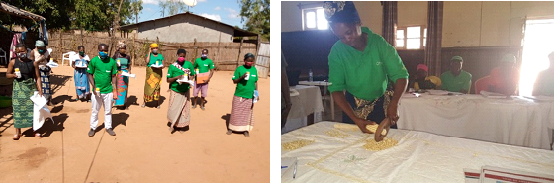
Figure 11. Left photo: beneficiaries receiving actelic; right photo: a woman CAE showing how to use mechanic thresher she received.

2.11. Establishment of business linkages between seed suppliers and farmers
- Target: 20 meetings * Achieved: 29 meetings (145%)
The project organized 29 meetings between CAEs and agro-dealers in 10 districts during 3 years. The meetings aimed to establish business linkages between CAEs and agro-dealers through actors mapping and exchanging of phone numbers. The major contents of the meetings were:
- Introduction of CAEs’ role in the value chain;
- Introduction of agrodealers’ role in the value chain;
- Actor mapping and exchanging of phone numbers;
In 3 years, the meetings brought excellent results; a total of 28 agrodealers are well linked with 106 CAEs in 9 districts as shown in the appendix 4. These agrodealers are reporting that on one hand, business volume has increased, and on the other hand, they replace stock on time and based on demand. Regarding to CAEs, they reported that apart from margins they get, there is a feeling that the inputs are closer to smallholder farmers. The figure below shows some meetings held in the project.
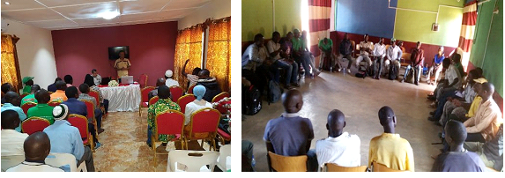
Figure 12. Left photo: Open speech during the first meeting in Cuamba; right photo: a strategy discussion between CAEs and agro-dealers in Malema

2.12. Graduation of Community Agribusiness Entrepreneur
- Target: 404 * Achieved: 404 (100%)
The graduation of CAEs was not part of this project activities. However, during the project implementation CAEs demanded it. They argued the following: (i) there was a request from part of SMEs for an identification as CAEs to avoid business opportunists; (ii) the CAEs were trained in several topics, but they had no any document to evidence that; and (iii) the CAEs concluded that their business as CAEs was sustainable, however, for mid and long-term the business could be at risk due to lack of certificate to prove their role to partners, including buyers and agro-dealers.
The project analyzed the arguments and recognized that the CAEs deserve certificates and a project farewell graduation ceremony. Therefore, the project used the amount budgeted to field days, but did not happen due to Covid-19 to arrange graduation ceremonies in all 10 districts. CAEs received certificates and a farewell speech was made. The first certificate was given to Paulino Constantino in the hands of the Secretary of State of Nampula province as shown in the figure 14, thereafter followed the remaining CAEs in the districts. Total of 404 CAEs (118 women) were graduated.
Table 14. Number of graduated CAEs per district.
Province | District | Global |  | Total
Province | District | Sex |  | Total
Province | District | Male | Female | Total
Nampula | Malema | 28 | 16 | 44
Nampula | Meconta | 21 | 19 | 40
Nampula | Monapo | 23 | 17 | 40
Nampula | Murrupula | 35 | 5 | 40
Nampula | Rapale | 28 | 12 | 40
Nampula | Ribáuè | 28 | 12 | 40
Niassa | Cuamba | 34 | 6 | 40
Niassa | Mecanhelas | 30 | 10 | 40
Zambézia | Alto-Molocué | 24 | 16 | 40
Zambézia | Gurué | 35 | 5 | 40
Total |  | 286 | 118 | 404

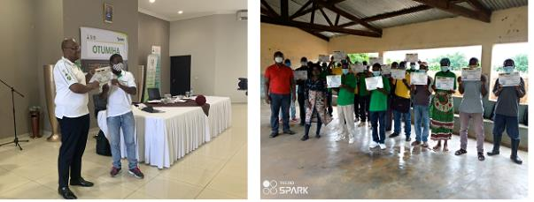
Figure 13. Left photo: Paulino Constantino receiving certificate in the hands of Secretary of State; right photo: graduation ceremony in Malema.

2.13. Creation of climate smart demonstration plots
- Target: 10 * Achieved: 10 (100%)
In the last years, the climate change is a theme debated worldwide and that worries the humankind. Mozambique due its location is being affected by several extreme events such as cyclones, floods, strong winds, drought, etc. These events affect the agriculture and create negative impacts in the farmers lives. Therefore, the project implementation was also focused on dissemination of technologies and practices that are resilient to climate change. The project promoted in the 10 districts (Malema, Meconta, Monapo, Murrupula, Rapale, Ribáuè, Cuamba, Mecanhelas, Alto-Molocué and Gurué) short cycle varieties of maize (MZ523 and Molocue) and soybean (Sana and Zamboane) that are drought tolerant. Besides, in the districts of Monapo, Meconta and Murrupula, where the drought is prone, the project promoted use of mulching.
Significant changes are visible on the acceptance of those practices and technologies. About 9,512 farmers bought seeds of soybean and sown in their field, and about 46 farmers out 52 visited in Meconta reporting that are using mulching.
Yet, the project promoted solar pumps for irrigation. The project purchased 10 solar pumps from Babaji Sociedade Unipessoal Lda., an enterprise based in Nampula. The solar pumps were imported from India. The solar pump system, and it is composed by main pump, 4 solar panels, and one electric box where the energy capped by the solar energy is converted by the solar panels.
The project assessed group of farmers and farmer’s associations to select one group per district, as model. The farmer groups or associations created blocks of production of at least 3 ha (in the first year) to cultivate whole year even in the season when they had shortage of rain. The solar pumps are seen as good solution to respond effectively to climate change effects, such as drought.
To ensure transparency in the allocation process and sustainability of the pumps to be allocated, a joint (project team and SDAE) assessment to farmer groups was carried out. The assessment occurred in about 23 communities, an average of 2 communities per district. Items to be checked included water source availability, potential for irrigation and criteria for community eligibility. The following criteria were taken in account:
- Be an association or farmer group composed with a minimum of 15 members.
- Access to a water source that keeps water all over the year (enough water to irrigate the whole year).
- Members with capability of purchasing inputs (improved seeds and fertilizer) and to prepare land for production (manually or mechanized).
- Be able to make pumps maintenance (fix or purchase new tools to replace broken ones) with group funds.
- Use 30% of total area to cultivate hybrid maize or soya.
After several meetings, 10 communities and groups were selected. The table 14 shows the community and group names. Total of 194 members (79 women) benefited from the solar pumps. During project implementation 19 production fields were established.

Table 15. Name of selected communities and groups
Province | District | Name of the community | Area (ha) | Number of beneficiaries |  | Name of the group
 |  |  |  | Male | Female | Name of the group
Nampula | Malema | Nanari | 2 | 8 | 14 | Associação Nanai de Maria madeira
Nampula | Meconta | Cumanha | 3 | 8 | 2 | Brilho do Dia
Nampula | Monapo | Mugica | 1 | 11 | 7 | Grupo das mulheres poderosas
Nampula | Murrupula | Naminhapa | 2 | 10 | 10 | Group of Naminhapa
Nampula | Rapale | Cuhari | 2 | 14 | 11 | Muassiua
Nampula | Ribáuè | Namakucku | 3 | 7 | 3 | Olima Orera
Niassa | Cuamba | Nincare | 4 | 10 | 5 | Produtores da Pecuária
Niassa | Mecanhelas | Tobue | 1 | 11 | 5 | Nchemo
Zambézia | Alto-Molocué | Machilone | 1.5 | 21 | 12 | Ophwanha
Zambézia | Gurué | Lioma | 4 | 15 | 10 | Futuro Melhor de Mulapana
Total |  |  | 23.5 | 115 | 79

Up to the project end, there were 3 groups (from Cuamba, Meconta and Ribáuè districts) out 10 that showed rapid improvement. The aspect that differentiates the 3 groups to others is having market orientated farmers as members; while other groups are association of farmers, which their mindset was built based on offers from projects without any business/market orientation. Therefore, Otumiha project has been working progressively to change these farmers’ mindset for 2 years.

The 3 groups mentioned above, specifically from Meconta and Cuamba have increased production area from 2ha to 4ha. In Meconta, farmers are cultivating cabbage, tomato and aborigine; in Cuamba, farmers are cultivating onion only. For example, according the production plan of Cuamba group, in 4ha, they invested almost 700,000MZN as production costs, they expected to harvest about 65,000kg of produce. They are planning to sell at price of 35MZN/kg to earn about 2,245,000MZN. The figure below shows the onion crop in the field, in Cuamba district, “Grupo da Pecuária”.

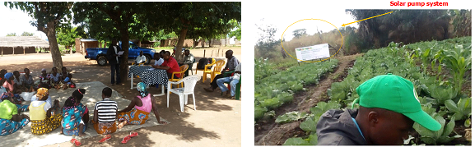
Figure 14. Left photo: assessment process for selection of groups in Cuamba; right photo: production field using solar pump system in Ribáuè.

2.14. Leverages
In the extension, the leverages were:
- Inputs from private sector for demo plots.
Table 16. Benefits from private sector to the project beneficiaries in kind.
Institution | Type of input | Quantity (kg) | ~ Benefited value to the project beneficiaries (MZN) | Value in USD
Seed company –K2 | Hybrid seed of maize | 500 | 80,000 | 11,428
Seed company- PANNAR | Hybrid seed of maize | 640 | 102,400 | 1,462
Seed company - Syngenta | Hybrid seed of maize | 400 | 64,000 | 914
Seed company - Oruwera | Hybrid seed of maize | 50 | 7,000 | 100
Seed company – SEED*CO | Hybrid seed of maize | 390 | 54,600 | 780
Seed company – SEED*CO | Fertilizer | 600 | 26,400 | 377
Total |  |  | 334,400 | 15,061

- In kind or service from public sector
The project signed Memorandum of Understanding with SDAEs of Monapo, Ribáuè, Malema, Cuamba and Alto-Molocué. Ten (10) public extension workers (2 from each district) were allocated to assist project Otumiha beneficiaries on post-harvest trainings, delivering materials activities, business linkage meetings during 6 months (from April to September 2020). Thus, the government paid salaries to public extension workers and provided 10 motorbikes for this process. The project estimated that these public extension workers dedicated 70% of their time to project during this period.
Table 17. Benefits from public sector to the project beneficiaries in delivering services
Institution | Number of public extension workers | Estimated salary per month per public extension workers (MZN) | Allocated months to the project | Allocated time to the project (%) | ~ Benefited value to the project beneficiaries (MZN) | Value in USD
SDAE of Monapo | 2 | 16,000 | 6 | 70 | 134,400 | 1,920
SDAE of Ribáuè | 2 | 16,000 | 6 | 70 | 134,400 | 1,920
SDAE of Malema | 2 | 16,000 | 6 | 70 | 134,400 | 1,920
SDAE of Cuamba | 2 | 16,000 | 6 | 70 | 134,400 | 1,920
SDAE of A-Molocué | 2 | 16,000 | 6 | 70 | 134,400 | 1,920
Total |  |  |  |  | 672,000 | 9,600
Table 18. Benefits from public sector to the project beneficiaries in delivering materials
Institution | Number of bikes | Estimated value of motorbike in 5 years (MZN) | Estimated value of motorbike per year | Months allocated to the project | Allocated time to the project (%) | ~ Benefited value to the project beneficiaries (MZN) | Value in USD
SDAE of Monapo | 2 | 320,000 | 26,666 | 6 | 70 | 18,666 | 266.66
SDAE of Ribáuè | 2 | 320,000 | 26,666 | 6 | 70 | 18,666 | 266.66
SDAE of Malema | 2 | 320,000 | 26,666 | 6 | 70 | 18,666 | 266.66
SDAE of Cuamba | 2 | 320,000 | 26,666 | 6 | 70 | 18,666 | 266.66
SDAE of A- Molocué | 2 | 320,000 | 26,666 | 6 | 70 | 18,666 | 266.66
Total |  |  |  |  |  | 93,330 | 1,333.3

III. Achievements
OBJECTIVE | Intermediary outcome | ACTIVITY | OUTPUT | OUTCOME
Objective 1 - Increased staple crop productivity for smallholder farmers | 1.2 Increased production of appropriate blends and other soil management technologies | Identify and train Village based advisors (VBAs) | - Cumulative: 404 VBAs (CAEs) identified and trained | About 40,000 SHFs (20%) have adopted at least one technique or technology disseminated in the demo plots such as planting in line, use of correct density of plants, use of improved seed, fertilizer, growing of soya as new crop, etc.  About 9,512 farmers bought seed of soya  5 MoU signed with SDAEs of Monapo, Malema, Ribáuè, Cuamba and Alto-Molocué  28 agro-dealers and 106 CAEs have established very strong business relationship.  More 10 farmers adopted improved barns in the Chapala community, Alto-Molocué district. Currently, there are 19 farmers who adopted these barns.  About 37,563 (16,924) farmers have adopted at least 1 postharvest technique or technology. The most adopted techniques were drying of grain under cemented floors, or plastics, or tarps, and moisture control using bottle and salt
 |  | 1.1.2.2 Establish demonstration plots to show seeds performance | - Cumulative: 2,227 demos were established
 |  | 1.1.2.1 Train to build capacity of farmers and other value chain actors along focus value chains | - Cumulative: 2,793 training events conducted
 | 1.3 Increased use of inputs and other improved technology innovations | 1.1.3.1 Support market information systems | - Cumulative: 8,360 market information systems supported
 |  | 1.1.3.2. Facilitate farmers accessing market information supported by AGRA | - Cumulative: 16,224 farmers accessed market information supported by AGRA
 |  | Distribute small packs to farmers | - Cumulative: 284,194 small packs distributed to farmers
 |  | 1.1.3.2 Set contracts with local radio to disseminate inputs and marketing messages | - Cumulative: 27 contracts signed with local radios (9 contracts per year)
 |  | 1.1.3.3 Facilitate farmers to participate in AGRA supported extension services | - Cumulative: 203,450 farmers participated in AGRA supported extension services
 |  | 1.1.3.4 Conduct filed days | - Cumulative: 41 field days were carried out.
 |  | 1.1.3.5 Organize field days to demonstrate new improved varieties, technologies and create adoption. | - Cumulative: 6,788 people participated in the field days.
 |  | 1.1.3.6 Set up trade fairs | - Cumulative: 12 fairs organized
 |  | 1.1.3.7 Establish business linkages between seed supplies and farmers | - Cumulative = 29 meetings held.
 | 1.4 Increased access to focus agricultural value chain knowledge/ information | 1.1.4.1 Set contracts with mobile companies to disseminate messages/information to beneficiaries | - Cumulative: 3 contracts signed with Vodacom mobile Company (one contract per years).
Objective 2 - Strengthened and expanded access to output market | 3.1Increased access to improved crop storage infrastructure | 2.3.1.1 Promote/ demonstrate hermetic bags /raffia treated as storage solutions. | - Cumulative: 4 Technologies solutions were promoted and demonstrated.
 | 3.2: Increased use of improved post-harvest technologies and practices by small holder farmers | 23.2.1 Disseminate post-harvest and market messages | - Cumulative: 14,211 messages
 |  | 3.2.3 Distribute post-harvest material to farmers | - Cumulative: 14,570 post-harvest materials distributed to farmers
3. Increased practice of smart agriculture | In Increased use of smart agriculture technologies | P Promote the use smart agriculture technologies | - Cumulative: 10 farmers groups revoiced 10 solar pumps to use for irrigation in whole year. | 3 farmer groups (Cuamba, Ribáuè and Meconat) have improved their income in more than 100%

IV. Challenges in carrying out the project activities.
During the project implementation there were many challenges. Here, we picked up the major challenges faced based on the potential impact in the results:
- Fall Armyworm was the greatest pest for maize in the last years. This problem was minimized by the release of two (2) pesticides, emperator and belt;
- Extreme variation of climatic shochs affected production severely. For example, Alto-Molocué, Malema, Ribáuè and Cuamba districts the farms were constantly affected by floods and strong winds. While, Monapo, Meconta, Murrupula and Rapale districts had farms constantly affected by drought;
- There are few seed and fertilizer companies or their branches in Nacala Corridor. Therefore, sometimes, there is a lack of inputs at planting time;
- In the election period, there was a significant number of CAEs that were used as political campaign promoters. This could have affected the relationships between farmers and CAEs, especially for those who belong to different political parties;
- Although some post-harvest technologies such as metallic silos and mechanic threshers were considered very important by farmers, their availability is very limited, because there are very few manufacturing companies. And this limited supply raises price too, which affects affordability of the technologies to farmers;
- The CoViD-19 pandemic had strong impact on project activities, once the extension activities are characterized by group discussions, regular meetings between technicians, CAEs, facilitators and other farmers, etc. For example, field days had to be cancelled due to restrictions on the number of people in public events;
- During Covid-19, prices fluctuated abnormally, this created uncertainties in the market. It was visible that smallholder farmers were not clear about which messages and from whom they should trust;
- During Covid-19, the CAEs struggled to aggregate much produce, because their farmers’ network preferred to sell the produce directly to buyers instead of aggregating and selling in bigger volumes allowing more bargaining power;
- Under covid-19, the project always had to adapt the activity plans to respect and comply with the country new CoVid-19 prevention Norms. There were 2 phases decreed by government, being the first one “State of Emergency” and the second one “State of Calamity”. The latter is still active.

V. Learned lessons
During the project implementation there were many learned lessons. Here, we picked up the major ones:

- Maize sown early December (first 2 weeks) had less Fall Armyworm attack than maize sown after that period. However, planting should be done when it rains regularly, otherwise, crop could be lost (particularly hybrid maize);
- Soybean had better performance when it was sown between late January and early February across the target districts;
- Maize and soybean crops performed better in the districts located in upland areas such as Gurué, Alto Molocué, Malema and Cuamba than those located in lowland areas, such as Monapo, Meconta, Murrupula and Rapale;
- The strategy of engaging woman CAE to assist other women farmers increased women participation in the project activities;
- Farmers very aware about market linkages (or with market orientation) are more likely to purchase improved inputs, use post-harvest techniques and technologies, and invest in production area expansion;
- The CAEs or farmers’ network that aggregated much quantity of produce had more bargaining power and major likelihood to get bigger margins than others selling individually and with low volumes;
- The creation of facilitator figure (in the extension delivery model) brought great results to the project. Firstly, it improved the quality of assistance to the smallholder farmers by creating closeness; secondly, it increased the number of covered beneficiaries in short period; thirdly, it reduced the pressure over the CAEs and lastly, the facilitators could easily replace CAEs when they abandon the role played in the communities;
- The younger educated individuals (youth) with a market vision (entrepreneur mindset) were better suited to succeed as CAEs in terms of engaging more farmers and disseminating messages (best practices and produce aggregation) than elder CAEs. And engaging more farmers means aggregating more volumes and getting higher margins, thus increasing income.

APPENDIX 1

- Mother demo (for CAE)
- 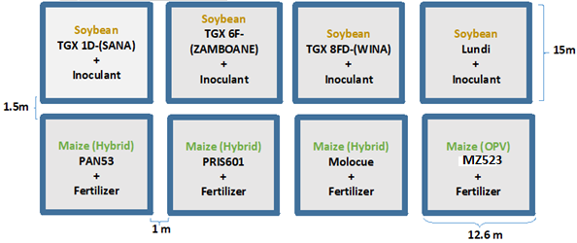
Figure 1. Crop varieties and layout of mother demo.
Planting space and fertilizer details
Maize: 90 cm x 40 cm (90cm between rows and 40cm within the row).
Fertilizer: Yara Mila Cereal 100 kg/ha (one application) and Urea 46% 100kg/ha (two applications).
Soya: 50 cm x 15 cm (50cm between rows and 15cm within the row).

- Baby demo (for facilitators)
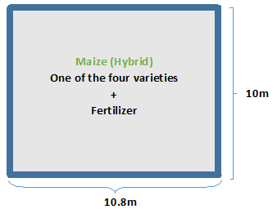
Figure 2. Crop variety and layout of baby demo
Planting space and fertilizer details
Maize: 90 cm x 40 cm (90cm between rows and 40cm within the row)
Fertilizer: Yara Mila Cereal 100 kg/ha (one application) and Urea 46% 100kg/ha (two applications).
APPENDIX 2
Material for Good Agricultural Practice (GAP)

APPENDIX 3
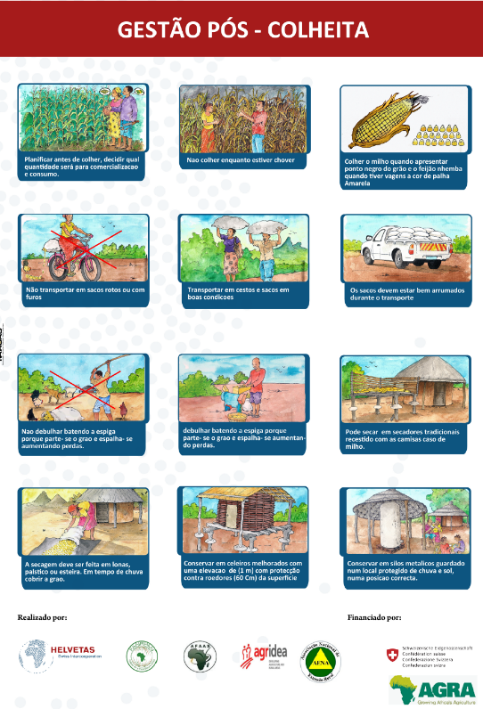

Posters of Post-harvest and markets messages

APPENDIX 4
List of well-established linkages between agro-dealers and CAEs

Agro-dealer | Contact | CAE | Contact | District
1. Patrício Penteque (Vila) | 861335585 | 1. Ajuma Constantino | 868995058 | Malema
1. Patrício Penteque (Vila) | 861335585 | 2. Augusto Tomás | 879476220 | Malema
1. Patrício Penteque (Vila) | 861335585 | 3. Hermínio Abel Vanacha | 866550487 | Malema
1. Patrício Penteque (Vila) | 861335585 | 4. Daniel Uehiua | 877796281 | Malema
1. Patrício Penteque (Vila) | 861335585 | 5. Waite Amisse | 845760823 | Malema
2. Agro Dalton (Vila) | 844085478 | 6. Estefánia Almeida | 845760823 | Malema
2. Agro Dalton (Vila) | 844085478 | 7. Florinda Inacio Maricoa | 869717615 | Malema
2. Agro Dalton (Vila) | 844085478 | 8. Januário Salimo | 869717615 | Malema
2. Agro Dalton (Vila) | 844085478 | 9. José Moisés Marapata | 874807481 | Malema
2. Agro Dalton (Vila) | 844085478 | 10. Luis Enriques | 874592109 | Malema
2. Agro Dalton (Vila) | 844085478 | 11. Aurora Manuel |  | Malema
3. Manuel Caetano (Mutuali) | 879079632 | 12. Abelino Alfredo | 879476220 | Malema
3. Manuel Caetano (Mutuali) | 879079632 | 13. Maria Da Fátima José |  | Malema
3. Manuel Caetano (Mutuali) | 879079632 | 14. Silvério Alberto |  | Malema
4. Jorge Felismino (Nioce) | 867549276 | 15. Novas João |  | Malema
4. Jorge Felismino (Nioce) | 867549276 | 16. Patrício Daniel |  | Malema
4. Jorge Felismino (Nioce) | 867549276 | 17. Valério Vicente |  | Malema
4. Jorge Felismino (Nioce) | 867549276 | 18. Manuel Eusébio |  | Malema
5. António Raul (Corrane) | 869518077 | 19. Artur Constatino Chereque | 864650030 | Meconta
5. António Raul (Corrane) | 869518077 | 20. Dias António Cantaneia | 871713363 | Meconta
5. António Raul (Corrane) | 869518077 | 21. Julião Manuel | 863967790 | Meconta
5. António Raul (Corrane) | 869518077 | 22. Américo Armando Silvestre | 846211728 | Meconta
5. António Raul (Corrane) | 869518077 | 23. Abril Agostinho Luciano | 867109941 | Meconta
5. António Raul (Corrane) | 869518077 | 24. António Manuel | 871759695 | Meconta
5. António Raul (Corrane) | 869518077 | 25. Xavier António | 866840166 | Meconta
5. António Raul (Corrane) | 869518077 | 26. Valdo Hilario Trigo | 878280215 | Meconta
6. Laura Luciano (Nacavala) | 842505559 | 27. Laura Aliante Maiuela | 846211728 | Meconta
6. Laura Luciano (Nacavala) |  | 28. António Abílio | 848613886 | Meconta
7. Lucia Cristovão (Corrane) | 878670826 | 29. Patrício Sérgio |  | Meconta
7. Lucia Cristovão (Corrane) | 878670826 | 30. Elias António | 877215264 | Meconta
7. Lucia Cristovão (Corrane) | 878670826 | 31. Bernardo Alberto Martinho | 867332074 | Meconta
8. Eusébio João (Corrane) | 867728155 | 32. Nelson Joao Sapatilha | 868664457 | Meconta
9. Luís Rede | 842833035 | 33. António Ernesto | 845902838 | Monapo
9. Luís Rede | 842833035 | 34. Alberto Gustavo |  | Monapo
9. Luís Rede | 842833035 | 35. Cesar Jaime |  | Monapo
9. Luís Rede | 842833035 | 36. Albisto António | 864078586 | Monapo
9. Luís Rede | 842833035 | 37. Amelia Silvio |  | Monapo
9. Luís Rede | 842833035 | 38. Emilio Albano |  | Monapo
9. Luís Rede | 842833035 | 39. Telma Monteiro |  | Monapo
10. Andre (Cooperativa de MORENO - Netia) | 863489524 | 40. Fernando Celestino |  | Monapo
10. Andre (Cooperativa de MORENO - Netia) | 863489524 | 41. Horacio Amisse |  | Monapo
10. Andre (Cooperativa de MORENO - Netia) | 863489524 | 42. Rafael Juma |  | Monapo
10. Andre (Cooperativa de MORENO - Netia) | 863489524 | 43. Mario Manuel |  | Monapo
11. Telma Americo Sinseque (Itoculo) | 846133626 | 44. Matano Roupave | 872159232 | Monapo
11. Telma Americo Sinseque (Itoculo) | 846133626 | 45. Eurico Mussa | 848398327 | Monapo
11. Telma Americo Sinseque (Itoculo) | 846133626 | 46. Telma Monteiro |  | Monapo
12. Domingos Muarrapaz (Murrupula) | 845362946 | 47. Adolfo Vicente | 844655602 | Murrupula
12. Domingos Muarrapaz (Murrupula) | 845362946 | 48. Alberto Manuel Cebola | 847022088 | Murrupula
12. Domingos Muarrapaz (Murrupula) | 845362946 | 49. Cheual Matonado | 847796239 | Murrupula
12. Domingos Muarrapaz (Murrupula) | 845362946 | 50. Jaime Raimundo Alvaro | 847203363 | Murrupula
12. Domingos Muarrapaz (Murrupula) | 845362946 | 51. Joao Albino | 873174707 | Murrupula
12. Domingos Muarrapaz (Murrupula) | 845362946 | 52. Antonio Paulo | 876741958 | Murrupula
12. Domingos Muarrapaz (Murrupula) | 845362946 | 53. Rafael Antonio | 876186823 | Murrupula
12. Domingos Muarrapaz (Murrupula) | 845362946 | 54. Agostinho Estevão | 865268090 | Murrupula
12. Domingos Muarrapaz (Murrupula) | 845362946 | 55. Dionísio João | 846986427 | Murrupula
12. Domingos Muarrapaz (Murrupula) | 845362946 | 56. Deodor Aroua | 866540650 | Murrupula
12. Domingos Muarrapaz (Murrupula) | 845362946 | 57. Victor Armando | 842666218 | Murrupula
12. Domingos Muarrapaz (Murrupula) | 845362946 | 58. Saide Manuel | 848007076 | Murrupula
12. Domingos Muarrapaz (Murrupula) | 845362946 | 59. Valeriano Dos Santos | 849459908 | Murrupula
12. Domingos Muarrapaz (Murrupula) | 845362946 | 60. Evaristo Maulete | 846271595 | Murrupula
13. Ernesto Gabriel (Namigonha) | 844568573 | 61. Edson Benedito |  | Ribaue
13. Ernesto Gabriel (Namigonha) | 844568573 | 62. Domingos Antonio | 874796540 | Ribaue
13. Ernesto Gabriel (Namigonha) | 844568573 | 63. Eldio Aborto | 868173743 | Ribaue
14. Joaquim Lancheque (MaviliII) | 849399340 | 64. Adelaide Gomes | 844403255 | Ribaue
14. Joaquim Lancheque (MaviliII) | 849399340 | 65. Rafael Chale | 861622621 | Ribaue
14. Joaquim Lancheque (MaviliII) | 849399340 | 66. Geelane Alberto | 866912668 | Ribaue
15. Justino Timba (Metucue) | 878894306 | 67. Angelina Benese | 863279993 | Cuamba
15. Justino Timba (Metucue) | 878894306 | 68. Faustino Morsone | 849638793 | Cuamba
15. Justino Timba (Metucue) | 878894306 | 69. Omar Remo | 877562736 | Cuamba
15. Justino Timba (Metucue) | 878894306 | 70. Horácio Biasse | 869744061 | Cuamba
15. Justino Timba (Metucue) | 878894306 | 71. Silvestre Diquissone | 879823046 | Cuamba
16. Samuel Aiwene (Vila) | 845451875 | 72. Berlinda Riberio | 865437409 | Cuamba
16. Samuel Aiwene (Vila) | 845451875 | 73. Jeremias Capuchone | 862240863 | Cuamba
17. Sozinho Niviho (Etatara) | 865986292 | 74. Carlos Romosse | 868073475 | Cuamba
17. Sozinho Niviho (Etatara) | 865986292 | 75. Monica Alberto | 867969595 | Cuamba
18. Xavier Nloco (Etatara) | 863899916 | 76. Francisco Manla | 849638793 | Cuamba
18. Xavier Nloco (Etatara) | 863899916 | 77. Frederico Macumula | 849628973 | Cuamba
19. Rafael Murramua (Lurio) | 868838107 | 78. Miguel Mussa | 874395275 | Cuamba
19. Rafael Murramua (Lurio) | 868838107 | 79. Nito Cesar | 864590366 | Cuamba
20. Rafael Jose (Sisaua) | 865464434 | 80. Alfredo Sandolo | 867323978 | Mecanhelas
20. Rafael Jose (Sisaua) | 865464434 | 81. Fabiao Daniel | 875025018 | Mecanhelas
21. Ganizani Daniel (Entrelagos) | 862317241 | 82. Salvador Chipa | 865425077 | Mecanhelas
21. Ganizani Daniel (Entrelagos) | 862317241 | 83. Felizmino Ângelo | 879762060 | Mecanhelas
21. Ganizani Daniel (Entrelagos) | 862317241 | 84. Paula Pereira | 864119731 | Mecanhelas
21. Ganizani Daniel (Entrelagos) | 862317241 | 85. Adamo Buanassenje | 879788481 | Mecanhelas
22. Sebastião Jaquissone (Chiuta) | 867414632 | 86. Cassimo Dickson Maulana | 877460744 | Mecanhelas
23. Magaissa Loulene (Tobue) | 862473359 | 87. Alberto Jairosse | 877718525 | Mecanhelas
24. Tongai (Magigi) | 840767796 | 88. Abilio Catxingue | 876225521 | Gurue
24. Tongai (Magigi) | 840767796 | 89. Abreu Joaquim | 861690300 | Gurue
24. Tongai (Magigi) | 840767796 | 90. Florêncio Martinho Afonso | 840525197 | Gurue
24. Tongai (Magigi) | 840767796 | 91. Jaime Jaquisson | 863369787 | Gurue
24. Tongai (Magigi) | 840767796 | 92. Luisa Jamuce | 867604800 | Gurue
24. Tongai (Magigi) | 840767796 | 93. Paulino Constantino | 861688681 | Gurue
24. Tongai (Magigi) | 840767796 | 94. Rosário Magaissa | 860828068 | Gurue
24. Tongai (Magigi) | 840767796 | 95. Silva Andre Chicomessa | 861692006 | Gurue
24. Tongai (Magigi) | 840767796 | 96. Tavares Armando | 865276195 | Gurue
24. Tongai (Magigi) | 840767796 | 97. Tavares Artur | 863 506 797 | Gurue
24. Tongai (Magigi) | 840767796 | 98. Zito Fazbem Mpiro | 862980536 | Gurue
25. Agricon (Vila) | 852183086 | 99. Lucas Vassiua | 861402831 | Gurue
25. Agricon (Vila) | 852183086 | 100. Suzania Fernando | 869773615 | Gurue
26. Agro-Rural (Vila) | 864849026 | 101. Ricardo Vasco |  | Alto Molocue
26. Agro-Rural (Vila) | 864849026 | 102. Diosa Agostinho |  | Alto Molocue
26. Agro-Rural (Vila) | 864849026 | 103. Abel Victorino | 876683361 | Alto Molocue
27. Janeiro Bernardo (Mugema) | 867003235 | 104. Mascarinho Artur | 874591855 | Alto Molocue
27. Janeiro Bernardo (Mugema) | 867003235 | 105. Bernardo Ernesto | 865282524/867561785 | Alto Molocue
28. Ernesto Paulo (Soares/Caperula) | 841764173 | 106. Afonso Lopes | 866254684/845835336 | Alto Molocue

SME: Small-Medium Enterprise
SDAE: District Services of Economic Activities
CAE: Community Agri-business Entrepreneur
SDAE: District Services of Economic Activities

